**SAVEETHA SCHOOL OF ENGINEERING**

**CSA1142-OBJECT ORIENTED ANALYSIS AND DESIGN**

**QUESTION 16: VEHICLE REGISTRATION SYSTEM**

**USE CASE**

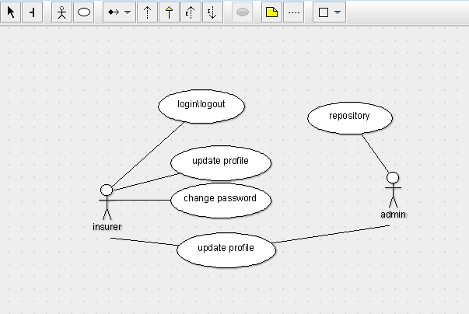

STATE DIAGRAM

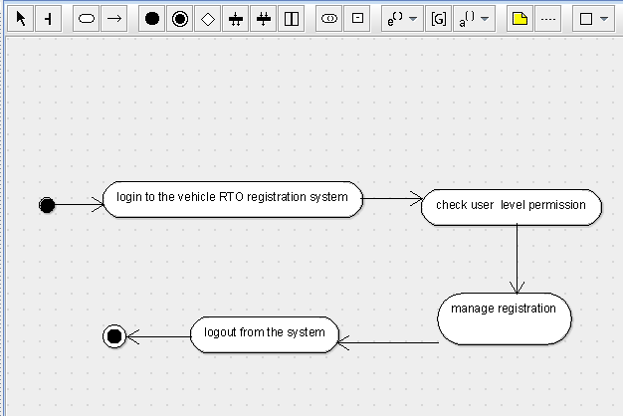

SEQUENCE DIAGRAM

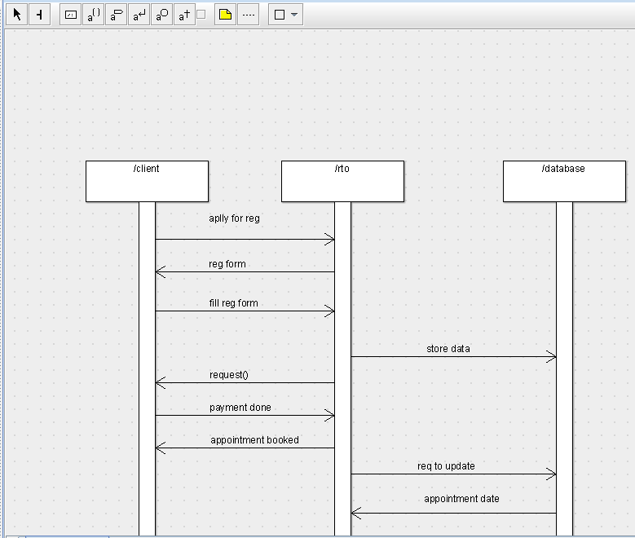

DEPLOYMENT DIAGRAM

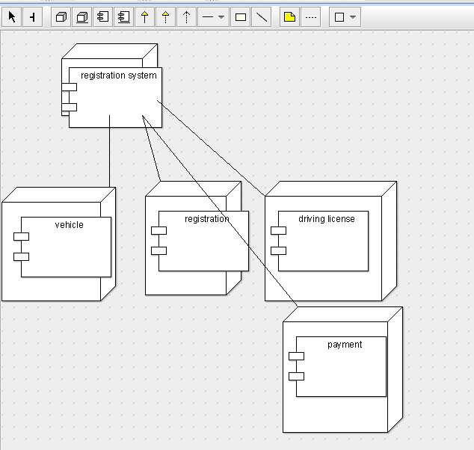

COMPONENT DIAGRAM

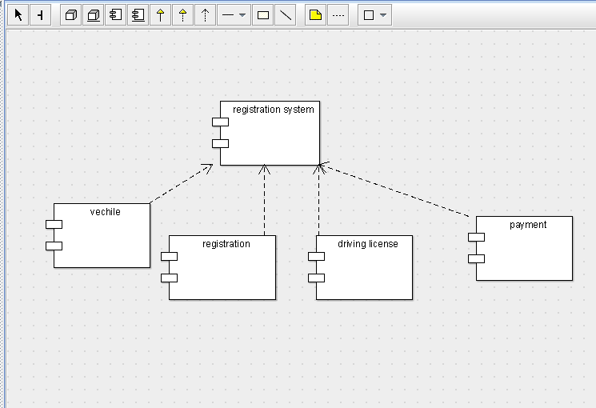

COLLABORATION DIAGRAM

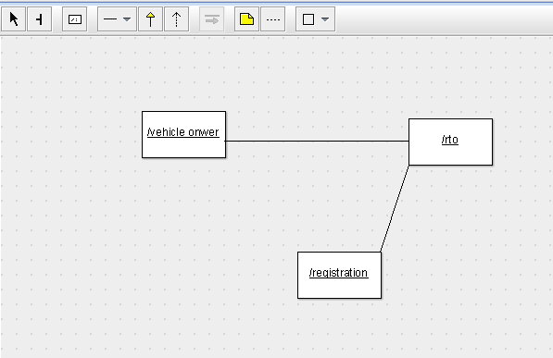

CLASS DIAGRAM

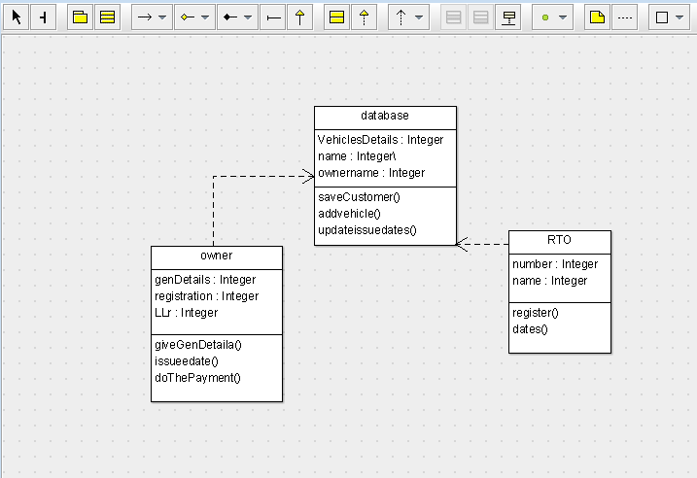

ACTIVITY DIAGRAM

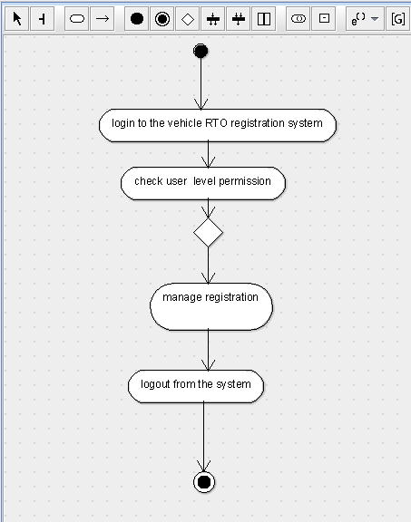

SKELETON CODE;

public class database {

  public Integer VehiclesDetails;

  public Integer\ name;

  public Integer ownername;

  public void saveCustomer() {

  }

  public void addvehicle() {

  }

  public void updateissuedates() {

  }

}

public class RTO {

  private Integer number;

  public Integer name;

  public void register() {

  }

  public void dates() {

  }

}

public class owner {

  public Integer genDetails;

  public Integer registration;

  private Integer LLr;

  public void giveGenDetaila() {

  }

  public void issueedate() {

  }

  public void doThePayment() {

  }

}

public class owner {

  public Integer genDetails;

  public Integer registration;

  private Integer LLr;

  public void giveGenDetaila() {

  }

  public void issueedate() {

  }

  public void doThePayment() {

  }

}